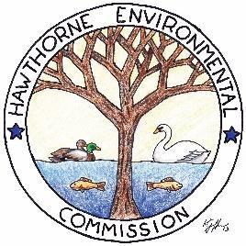
Kids Corner Newsletter
Spring/Summer 2025

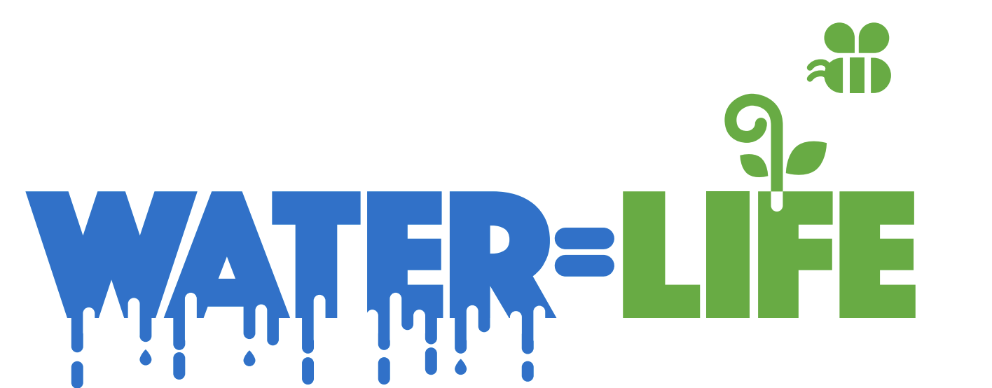

Water It's the most abundant substance on Earth's surface and is essential for life.
Water is the liquid that makes life on Earth possible. All living things, from tiny bacteria to giant blue whales, need water to survive. Without water, life as we know it would not exist. And life exists wherever there is water.
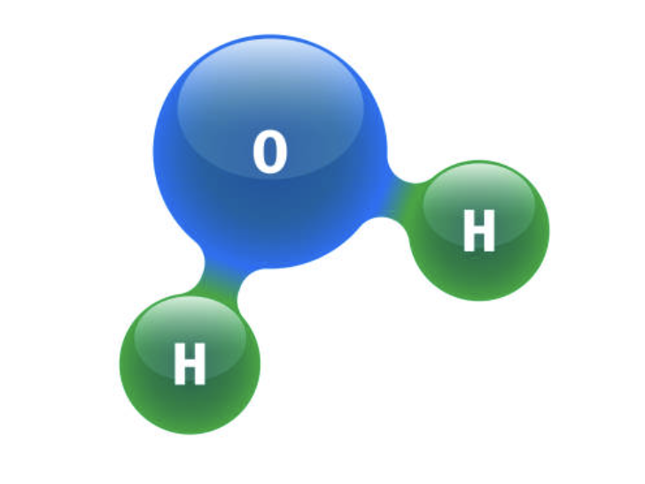
Water is everywhere! It makes up our oceans, lakes, rivers, seas, and even over half of our bodies. Water is a colorless, clear, odorless and tasteless liquid.

The chemical formula for water is H2O. Each water molecule contains two hydrogen atoms and one oxygen atom. It exists in liquid, solid, and gaseous states.
Nearly 97% of the world's water is salty or otherwise undrinkable. Another 2% is locked in ice caps and glaciers. That leaves just 1% for all of humanity’s needs — all its agricultural, residential, manufacturing, community, and personal needs.

Why is water important?
It gives us drinking water and is used for cooking, cleaning, and growing crops. We use it to drink, bathe, brush our teeth, water plants, and wash clothes. Water also helps animals survive and keeps nature healthy.

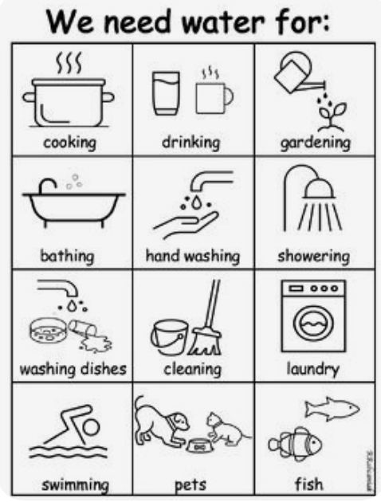
Interesting facts:

  - There is the same amount of water on Earth as there was when the Earth was formed.
  - Water can change forms: It can be a solid (ice), a liquid (water), or a gas (water vapor) depending on the temperature.
  - Water expands by 9% when it freezes. Frozen water (ice) is lighter than water, which is why ice floats in water.
  - Nearly 97% of the world's water is salty or otherwise undrinkable.
  - Water regulates the Earth's temperature.
  - 75% of the human brain is water and 75% of a living tree is water.
  - The average total home use for each person in the U.S. is about 50 gallons a day.

Where does water come from?
Water is found in many places: oceans, rivers, lakes, glaciers, icecaps, soil, aquifers, and in the air as water vapor. So how does it get here? A process called the water cycle.

There are four main steps to the water cycle:
Evaporation
Water evaporates from oceans, lakes, and rivers due to heat from the sun heats water in oceans, lakes, and rivers, causing it to evaporate into water vapor.

Condensation
As the water vapor rises, it cools and turns back into water droplets, forming clouds.

Precipitation
When the clouds get full, the water falls back to Earth as rain or snow.

Collection
The water that falls to Earth runs off into rivers, lakes, and oceans, where it can evaporate again.
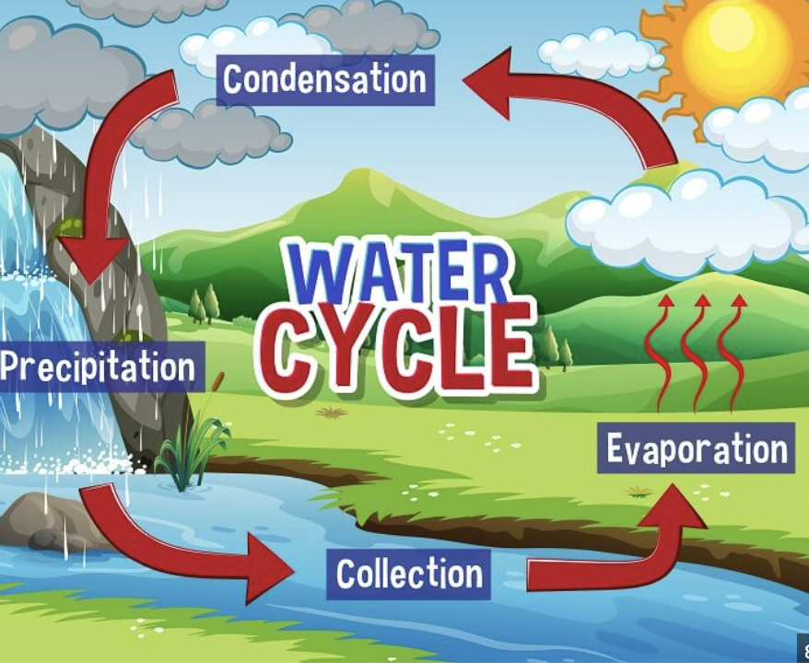

Conservation
The practice of using water efficiently and reducing unnecessary water usage is called conservation. Saving our water is important to keep our oceans, rivers and streams clean, and protect our planet's aquatic animals
Ways to Conserve Water
- Kids can save water at school by turning off the tap when not in use, taking shorter showers, and using water-efficient devices.
- Make sure a reusable water bottle is in everyone's backpack this year to stay hydrated and reduce waste.
- Turn off the tap while you brush your teeth. When washing your hands, turn the water off while you lather.
- Take 5-minute showers instead of baths.
- Run the washer and dishwasher only when they are full.
- Use a bucket for shower water to use for watering plants.
- Use a broom instead of a hose to clean driveways and paved areas
- Take 5-minute showers instead of baths.
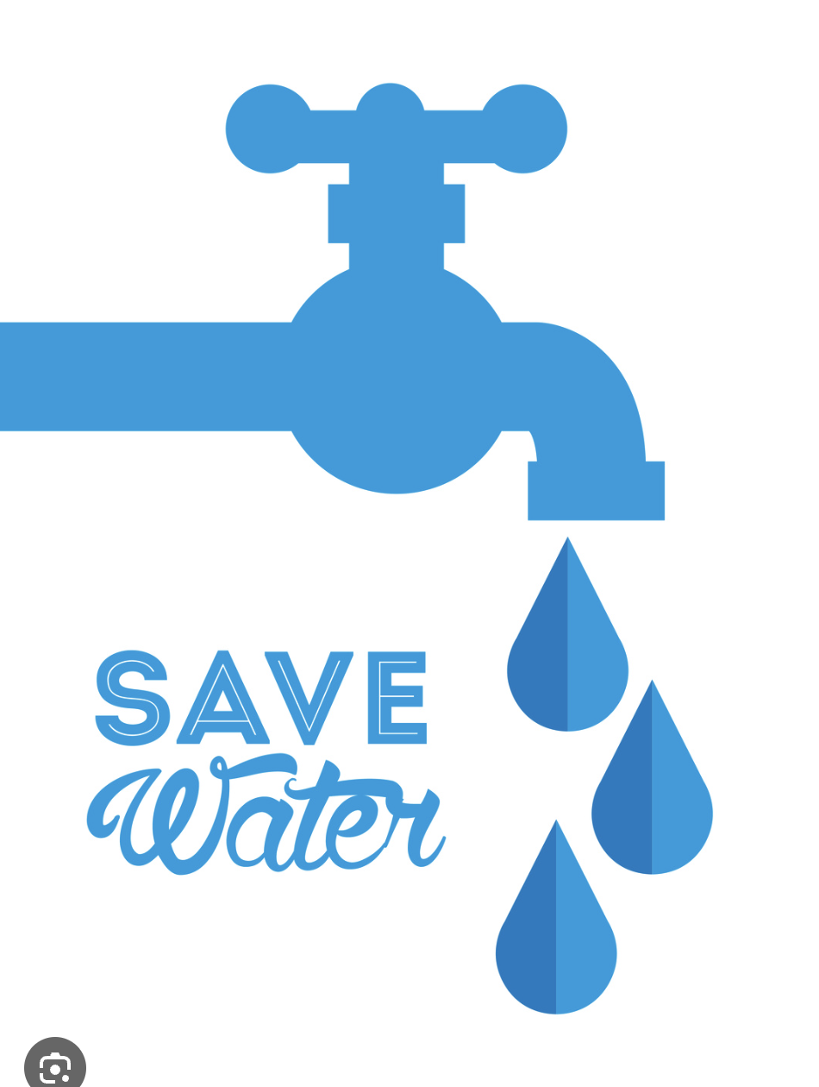
- Drop tissues in the trash instead of flushing them and save water every time.

